5.2.1.3 Guidance method’s questionnaire.

As was for the blind users, the sighted user also answered the Guidance questionaire to give their thoughts about their experience as BVI users. This way is possible to compare their feelings of confort and safety and compare with the blind users. The Table 5.48 shows the score of both groups of each method and they are plotted in the Figure 5.61.

TABLE 5.48 – Guidance method questionnaire score grouped by participant.

|  |  |  |  |  |  |
| --- | --- | --- | --- | --- | --- |
| Participant | Audio | Haptic  Belt | Virtual  Cane | Mixture | Visual Condition |
| 001 | 0.75 | 0.49 | 0.57 | 0.69 | Sight |
| 001C | 0.77 | 0.54 | 0.63 | 0.87 | Blind |
| 002C | 0.86 | 0.74 | 0.54 | 0.93 | Blind |
| 003 | 0.76 | 0.54 | 0.54 | 0.78 | Sight |
| 003C | 0.93 | 0.57 | 0.54 | 0.74 | Blind |
| 004 | 0.86 | 0.60 | 0.79 | 0.76 | Sight |
| 004C | 0.88 | 0.49 | 0.40 | 0.73 | Blind |
| 005 | 0.61 | 0.57 | 0.75 | 0.84 | Sight |

The Figure 5.61 presents the average score of each group. It possible to see that both groups were pleased with the ”Audio” and ”Mixture” method. The difference lies in the preference between the ”Haptic Belt” and ”Virtual Cane”. The blind users tend to prefer the first while the sighted users tend to prefer the last.

The Figure 5.69 presents the scores distribution and it is posible to see that there is some similarity between the two groups, with the exception of the ”Virtual Cane”method, which has a wider distributiuon for the sighted users. Also, it seems that the ”Audio”and ”Mixture” are similar inside the sighted users, as it was with the blind users..

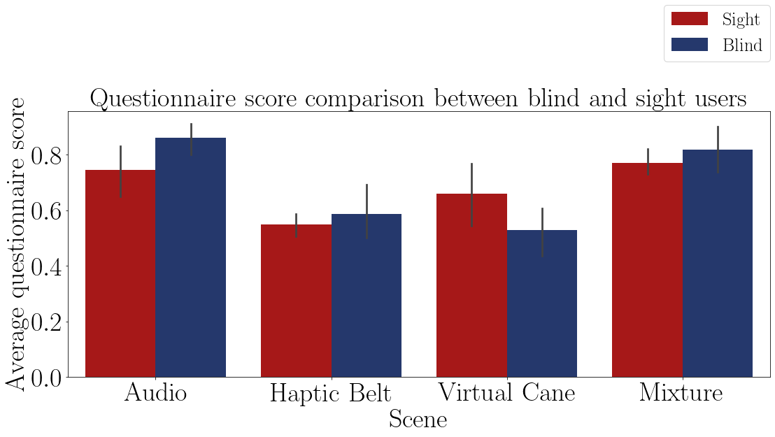

FIGURE 5.68 – Barplot of the average questionaire score of both participants on each method.

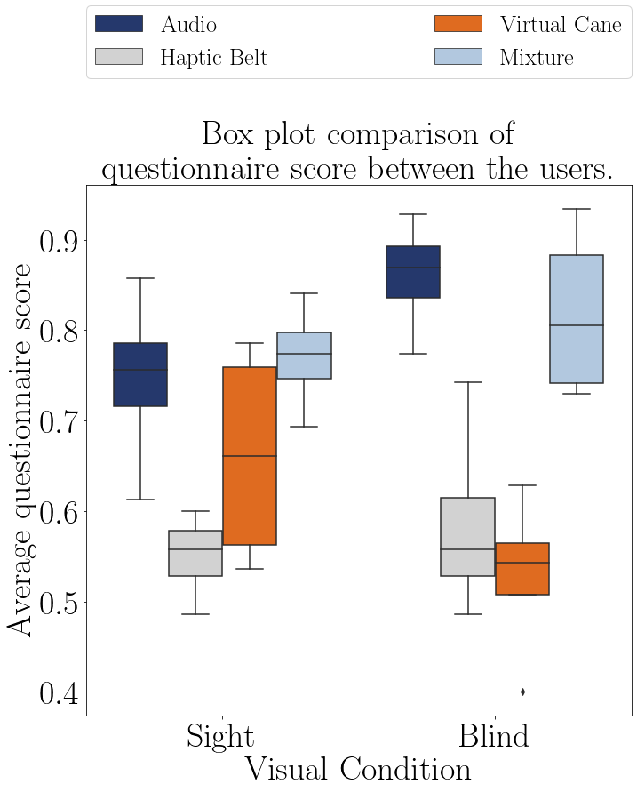

FIGURE 5.69 – Boxplot of the questionaire score of the the participants grouped by method.

The Table 5.49 show the the average questionnaire score on each method of both groups and it shows the same conclusion as the Figure 5.68, that the preference between the ”Haptic Belt” and ”Virtual Cane” is the only difference between the two groups.

Considering the most preferable and the less preferable of each group, the blind users

are score their choices more intesiver than the sighted users. This may be an effect from their previous experience with the ”Audio” method in previous events before the experiment and with haptic devices were something very, or almost, new. For the sighted users everything was new, so there scores were more consistent. This is posible to see in the average and standar deviation of these scores. For the blind users is 0.7 and 0.164 and for the sighted user is 0.682 and 0.100.

TABLE 5.49 – Guidance method questionnaire average score grouped by visual condition.

|  |  |  |  |  |
| --- | --- | --- | --- | --- |
| Visual Condition | Audio | Haptic Belt | Virtual Cane | Mixture |
| Blind | 0.86 | 0.59 | 0.53 | 0.82 |
| Sight | 0.75 | 0.55 | 0.66 | 0.77 |

The Figures 5.70 and 5.71 shows the distribution and variance of the Table 5.48. These Figures shows that the data are normally distributed and that the methods have a similar variance. The Table 5.50 shows the Anova test p-value of the questionnaire score of the ”sight”sample. The p-values indicates that the method have influence on the score.

Meaning that the participants had differents level os satisfaction about each method.

TABLE 5.50 – Anova p-value for the questionnaire score on each method for blinded users.

|  |  |  |  |  |  |
| --- | --- | --- | --- | --- | --- |
| Source | Squared sum | DOF | Squared average | F | P-Value  (*F*0 *>F*) |
| Participants (blocks) | 0.036 | 3 | 0.040 | 1.793 |  |
| Method | 0.119 | 3 | 0.012 | 5.954 | 0.016** |
| Experimental error | 0.060 | 9 | 0.007 |  |  |
| Total | 0.214 | 15 |  |  |  |

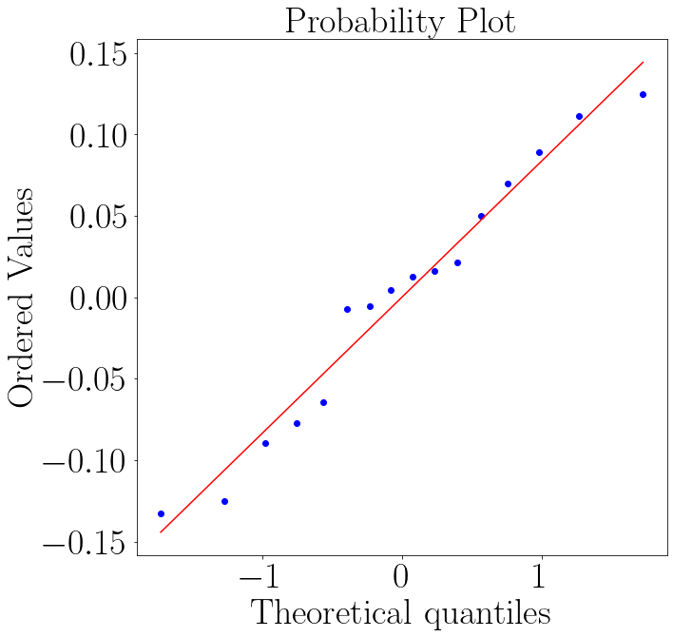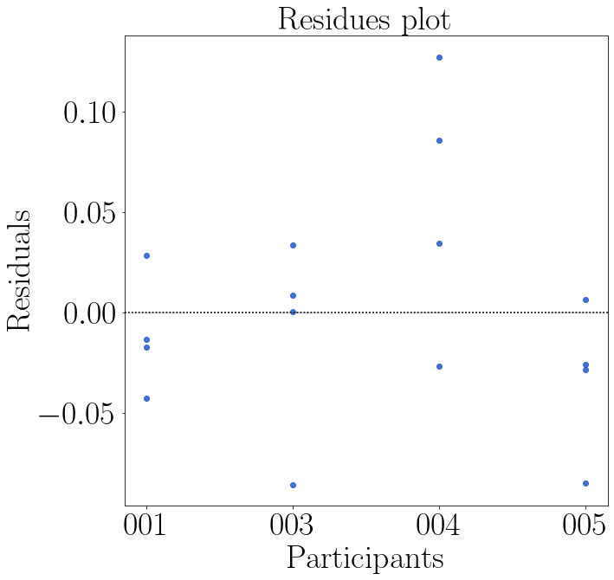

FIGURE 5.70 – QQ plot of the question- FIGURE 5.71 – Residual plot of the questionnaire score of the sighted participants on each naire score the sighted participants on each method. method.

The Table 5.51 presents the conclusion of a pairwise Fisher LSD test between all the guidance methods. The results are the same as the one for the ”blind” users. That only the ”Audio”and ”Mixture”have the same statistically result and that there is a difference between the both ”Haptic Belt” and ”Virtual Cane”.

TABLE 5.51 – Cross validation p-value for the questionnaire score on each method for blinded users.

|  |  |  |  |
| --- | --- | --- | --- |
| Method | | | Analysis |
| Audio | *X* | Haptic Belt | *H*1 : *µAudio* ̸= *µHapticBelt* ∗∗ |
| Audio | *X* | Virtual Cane | *H*1 : *µAudio* ̸= *µV irtualCane* ∗∗ |
| Audio | *X* | Mixture | *H*0 : *µAudio* = *µMixture* |
| Haptic Belt | *X* | Virtual Cane | *H*1 : *µHapticBelt* ̸= *µV irtualCane* ∗∗ |
| Haptic Belt | *X* | Mixture | *H*1 : *µHapticBelt* ̸= *µMixture* ∗∗ |
| Virtual Cane | *X* | Mixture | *H*1 : *µV irtualCane* ̸= *µMixture* ∗∗ |

The LSD Table 5.51 repeat the same conclusion of the blind participants, that only the ”Audio” and ”Mixture” are statistically the same. But that does not mean that both groups had the same opinion from the rest of the methods. As shown in the Figure 5.69, the average sighted user rather use the ”Virtual Cane” then the ”Haptic Belt”, despite that distribution being wider, hence more varied, meaning that this is hardly a consense between the users

…

…

…

#### 5.2.3 Final Remarks

Differently than the blind users, the results from the mental demand discipline of the NASA-TLX proved that the sight users felt a higher mental demand than the blind users.

The overall NASA-TLX score also proved a different conclusion than the one in the Section 5.1.1.1. For the sighted users, the round impacted more the overall score than the methods, whilst for the blind user were the opposite. This may be because the overall score is composed of 6 dimensions. Probably for the sighted user the mental demand score was higher and for the blind user it was not. But even so, the average score of the sight user was higher than the score of the blind user.

The Adapted SAGAT questionnaire for the sight users proved that the method impacts their situation awareness. The conclusion was different than the one proved by the blind users in the Section 5.1.1.2, who felt a bigger impact between the rounds than between the methods. The sight performance was also poorer than the blind user.

The Guidance Questionnaire of both groups had a similar distribution, both groups enjoy the same methods, ”Audio”and ”Mixture”. The difference was in the last two. The sighted users rather use the ”Virtual Cane” and the blind users rather use the ”Haptic

Belt”.

These conclusion show that the sighted users were more sensible to the methods than the blind users, although the effects were different. The blind users were more impacted by the methods than by the rounds, and when impacted by the methods, it was not possible to detect a pattern about the presence or not of a haptic device, as happened with the blind users.

The ECG sensors shown a difference in the heartrate between the methods, but the ANOVA test was not able to prove that difference, the same conclusion of the blind users in the Section 5.1.2.1. Another observation is that the heartrate frequency of the sighte user was higher than the blind users, meaning that their mental workload was probably higher.

According to the ANOVA test, The heartbeat variance also was not impact by the method or by the rounds, the same conclusion for the blind users in the Section 5.1.2.1. Graphically there was a small difference in the methods. Despite the results of the heartrate, the variance of the sight user was higher than the results from the blind user, meaning that the mental workload of the ”sight”sample was higher than the one of ”blind” sample.

The GSR ANOVA test also did not detect any impact from the methods or from the rounds, as it happened with the blind users in the Section 5.1.2.2. Graphically the sight user variations were very similar in all methods. This is a different effect than the one observed in the blind users, which graphically showed different GSR distributions on different methods. The sight GSR also show a small variation between the rounds and methods, which means that the sight user were not stressed or had a low mental workload during the experiment.

Despite the proved and not proved tests, there is a consideration to be made. The sight sample group profiling. As already explained before, the profile of the“blind”sample group was very wide and that can impact negatively in their performance. But the opposite effect may had happened with the“sight”sample group. This group was composed basically by researchers and engineer students, people that are typically involved with computers and technological devices, aging from 22 to 31 with an average of 27.5 years. This may biased the results with better performance when using the HMD and being able to feel present inside a virtual environment.

Besides these results, the “sighted” sample also commented the experiment. They all felt a lot more insecurity when walking, exploring and even when hand guided by the researcher before the start of the round. The “blind” sample group was already used to bumping their body when exploring new closed quarters. The “sighted” group did not want that to happen and approached the furniture with a lot more caution. They also noticed the lack of precision of the haptic devices, but they did rely more on then to navigate.

6 Conclusion

…

…

…

Do non-BVI users, when deprived from their vision, evaluate assistive devices in a similar way as BVI users?

Comparing the results from the analyzes of the ”blind”sample and the ”sight”sample one realizes that the groups felt different reaction. Most of the blind users felt a bigger impact between the rounds than by the methods, whilst the sight users felt a bigger impact by the method. The preference other has some minor differences too. The firsto two preferable methods are the same, and in both cases are statiscally the same, but the last two were different between the two groups.

This may be biased, since most of the conception of the devices was made by a sighted researcher, even thought there was recommendations from BVI researchers. But this may only reinterate that sighted users have a difficulty imagine how a blind users perceives the world and